**Introduction**

In these modern days finding car parking is a big issue in congested cities. There are too many vehicles on the road but not enough parking spaces. One of the biggest problems is when we enter a parking area then we realize that there are no empty parking slots to park our cars. Important time. Another biggest problem is after entering in a big parking area we confused to find the empty parking slot to park our car. Sometimes maybe we all have been facing these two problems that wasted our important time. That’s why we need efficient parking management systems in all parking areas that will provide confusion-free and easy parking.

In this tutorial, we will design a “Smart Parking System Project” to overcome this problem. This project helps the car’s driver to park their car with minimum wastage of time with accurate information of the availability of the space to park.

**Smart Parking System Concept**

This smart parking system project consists of Micro controller, IR sensors, servo motor, and one LCD display. Where the MCU is the main microcontroller that controls the whole system. IR sensors are used to detect the parking slot availability. The servo motor is placed at the entry and exit gate that is used to open and close the gates. Also, an LCD display is placed at the entrance, which is used to show the availability of parking slots in the parking area.

When a vehicle arrives at the gate of the parking area, the display continuously shows the number of empty slots. If there have any empty slots then the system opens the entry gate by the servo motor. After entering the car into the parking area, when it will occupy a slot, then the display shows this slot is full.

If there is no empty parking slot then the system displays all slots are full and does not open the gate.

**Working Principle**

There are four parking slots in this project, IR sensor-1, 2, 3, and 4 are placed at slot-1, 2, 3, and 4 respectively. A servo motor is used to operate the common single entry and exit gate. The LCD display is placed near the entry gate.

The system used IR sensor-1, 2, 3, and 4 to detect whether the parking slot is empty. In the beginning, when all parking slots are empty, then the LCD display shows all slots are empty.

In case the parking is full, the system blocked the entrance gate by closing the servo barrier. And the LCD display shows that slot-1, 2, 3, and 4 all are full.

When a vehicle leaves a slot, then the LCD display shows that the slot is empty. Again the system will allow entering a new vehicle.

**Radio-frequency identification (RFID)**

**Radio-frequency identification (RFID) is the use of a wireless non-contact system that uses radio-frequency electromagnetic fields to transfer data from a tag attached to an object, for the purposes of automatic identification and tracking. Some tags require no battery and are powered by the electromagnetic fields used to read them. Others use a local power source and emit radio waves (electromagnetic radiation at radio frequencies). The tag contains electronically stored information which can be read from up to several meters (yards) away. Unlike a bar code, the tag does not need to be within line of sight of the reader and may be embedded in the tracked object.**

**How RFID Works?**

**An RFID system consists of three components: an antenna or coil, a transceiver (with decoder) and a transponder (RF tag) electronically programmed with unique information. Fig. 1 shows a typical RFID system. In every RFID system, the transponder tags contain unique identifying information. This information can be as little as a single binary bit or a large array of bits representing such things as an identity code, personal medical information or literally any type of information that can be stored in digital Binary format.**

**Fig - 1**

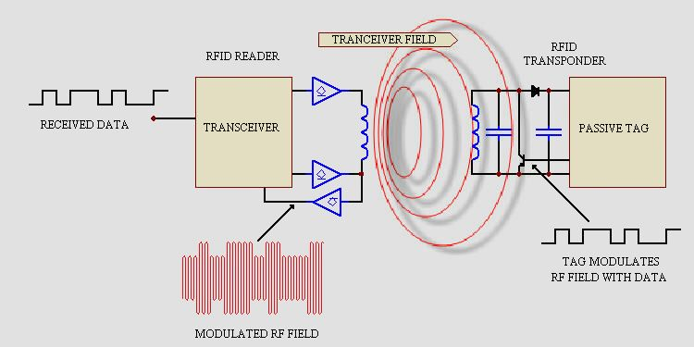

**The RFID transceiver communicates with a passive tag. Passive tags have no power source of their own and instead derive power from the incident electromagnetic field. Commonly, at the heart of each tag is a microchip. When the tag enters the generated RF field, it is able to draw enough power from the field to access its internal memory and transmit its stored information. When the transponder tag draws power in this way, the resultant interaction of the RF fields causes the voltage at the transceiver antenna to drop in value. This effect is utilised by the tag to communicate its information to the reader. The tag is able to control the amount of power drawn from the field and by doing so it can modulate the voltage sensed at the transceiver according to the bit pattern it wishes to transmit.**

**Antenna**

**Fig - 2**

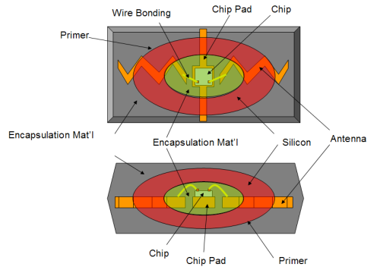

**Fig. 2 shows the internal diagram of a typical RFID antenna. An RFID antenna consists of a coil with one or more windings and a matching network. It radiates the electromagnetic waves generated by the reader to activate the tag and read/write data from it. Antennae are the conduits between the tag and the transceiver which control the system’s data acquisition and communication. These are available in a variety of shapes and sizes. Often, the antenna is packaged with the transceiver and decoder to become a**

**Reader, which can be configured either as a handheld or a fixed-mount device. The reader emits radio waves in ranges of anywhere from 2.54 cm (one inch) to 30 metres or more, depending upon its power output and the radio frequency used. When an RFID tag passes through the electromagnetic zone, it detects the reader’s activation signal. The reader decodes the data encoded in the tag’s integrated circuit (silicon chip) and the data is passed to the host computer for processing.**

**Tags (transponders)**

**Fig - 3**

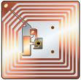

**Fig. 3 shows the internal structure of a typical RFID tag. An RFID tag comprises a microchip containing identifying information and an antenna that transmits this data wirelessly to the reader. At its most basic, the chip will contain a serialised identifier, or licence plate number, that uniquely identifies that item, similar to the way many barcodes are used today. There are three types of tags: active, passive and semi-passive. Passive tags have no internal power source. These draw their power from the electromagnetic field generated by the RFID reader and then the microchip can send back information on the same wave. The reading range is limited when using passive tags. Active transponders have their own transmitters and power source, usually in the form of a small battery. These remain in a low-power ‘idle’ state until they detect the presence of the RF field being sent by the reader. When the tag leaves the area of the reader, it again powers down to its idle state to conserve its battery. As a result, active tags can be detected at a greater range than passive tags. Semi-passive tags have their own power source that powers only the microchip. These have no transmitter. They rely on altering the RF field from the transceiver to transmit their data.**

**There are three ways for data encoding into tags:**

1. **Read-only tags contain data, which is pre-written onto them by the tag manufacturer or distributor.**
2. **Write-once tags enable a user to write data to the tag one time in production or distribution processes.**
3. **Full read-write tags allow new data to be written to the tag as needed and later other data can be rewritten over the original data**

**Typical Applications for RFID**

* **Automatic Vehicle identification**
* **Attendance system**
* **Bank locker system**
* **Car Parking system**
* **Access control system**
* **Library management system**
* **Product identification system**
* **Human / animal tracking system**
* **Inventory Management**
* **Work-in-Process**
* **Container/ Yard Management**
* **Document/ Jewellery tracking**
* **Patient Monitoring**

**RFID Reader interface**

**Radio Frequency Identification (RFID) Card Readers provide a low-cost solution to read passive RFID transponder tags up to 10 cm away. The RFID card reader read the RFID tag in range and outputs unique identification code of the tag at baud rate of 9600. The data from RFID reader can be interfaced to be read by microcontroller. A RFID reader communicates through port pin RB3 pins of the microcontroller for further processing.**

**When an authorised person having the tag enters the RF field generated by the RFID reader, RF signal is generated by the RFID reader to transmit energy to the tag and retrieve data from the tag. Thus on identifying the authorised person, using pre-stored ID from, EEPROM. MCU Operate servo motor in forward direction for 5 seconds to open Gate. After five seconds MCU operate motor in reveres direction closed the Gate for vehicle simultaneously, the LCD shows valid used ID. If the person is unauthorised, the LCD shows “INVALID USER” and the Gate doesn’t open.**

**Arduino Micro controller**

**This is the CPU (central processing unit) of our project. We are going to use a microcontroller of AVR family. The various functions of microcontroller are like I. sensor detection, LCD Display, Motor Control, and display the all information of various function on 16 x 2 LCD Display**

**WIFI communication**

WIFI is a wireless technology standard for exchanging data over short distances (using short-wavelength radio transmissions in the ISM band from 2400–2480 MHz) from fixed and mobile devices, creating personal area networks (PANs) with high levels of security. it was originally conceived as a wireless alternative to RS-232 data cables. It can connect several devices, overcoming problems of synchronization

WIFI technology is a short-range communications technology that is simple, secure, and everywhere. You can find it in billions of devices ranging from mobile phones and computers to medical devices and home entertainment products. It is intended to replace the cables connecting devices, while maintaining high levels of security.

The key features of WIFI technology are robustness, low power, and low cost. The WIFI Specification defines a uniform structure for a wide range of devices to connect and communicate with each other.

When two WIFI enabled devices connect to each other, this is called pairing. The structure and the global acceptance of WIFI technology means any WIFI enabled device, almost everywhere in the world, can connect to other WIFI enabled devices located in proximity to one another.

Connections between WIFI enabled electronic devices allow these devices to communicate wirelessly through short-range, ad hoc networks known as piconets. Piconets are established dynamically and automatically as WIFI enabled devices enter and leave radio proximity meaning that you can easily connect whenever and wherever it's convenient for you.

Each device in a piconet can also simultaneously communicate with up to seven other devices within that single piconet and each device can also belong to several piconets simultaneously. This means the ways in which you can connect your WIFI devices is almost limitless.

A fundamental strength of WIFI wireless technology is the ability to simultaneously handle data and voice transmissions. which provides users with a variety of innovative solutions such as hands-free headsets for voice calls, printing and fax capabilities, and synchronization for PCs and mobile phones, just to name a few.

The range of WIFI technology is application specific. The Core Specification mandates a minimum range of 10 meters or 30 feet, but there is no set limit and manufacturers can tune their implementations to provide the range needed to support the use cases for their solutions.

WIFI Module Connect to MCU Rx & Tx Pin. Its Communicate With MCU and Cloud Server. MCU Send Sensor Data To Cloud using WIFI Module.

**ESP8266 WIFI Module**

The ESP8266 WiFi Module is integrated TCP/IP protocol stack that can give any microcontroller access to your WiFi network. The ESP8266 is capable of either hosting an application or offloading all Wi-Fi networking functions from another application processor. Each ESP8266 module comes pre-programmed with an AT command set firmware, meaning, you can simply hook this up to your Arduino device and get about as much WiFi-ability as a WiFi Shield offers (and that's just out of the box)! The ESP8266 module is an extremely cost effective board with a huge, and ever growing, community.

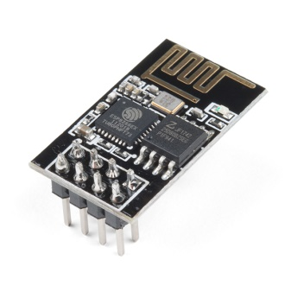

This module has a powerful enough on-board processing and storage capability that allows it to be integrated with the sensors and other application specific devices through its GPIOs with minimal development up-front and minimal loading during runtime. Its high degree of on-chip integration allows for minimal external circuitry, including the front-end module, is designed to occupy minimal PCB area. The ESP8266 supports APSD for VoIP applications and Bluetooth co-existance interfaces, it contains a self-calibrated RF allowing it to work under all operating conditions, and requires no external RF parts.

**Servo Motor Interfacing**

In the solar tracking, we are used servo Motor to change the position of Solar Panel. It is connect with micro controller port pin without any Ext Circuit.

Servos are motors that allow you to precisely control physical movement because they generally move to a position rather than continuously rotating. They are simple to connect and control because the motor driver is built right into them.

Servos contain a small DC motor connected to the output shaft through gears. The output shaft drives a servo horn and is also linked to a potentiometer (pot).

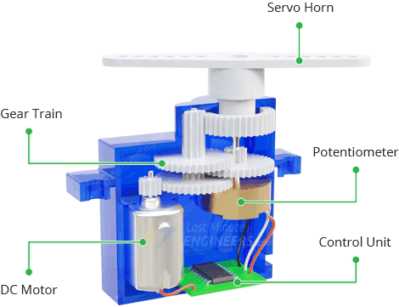

The potentiometer provides position feedback to the error amplifier in the control unit, which compares the current position of the motor to the target position.

In response to the error, the control unit adjusts the motor’s current position so that it matches the desired position.

**How Do Servo Motors Work?**

You can control the servo motor by sending a series of pulses to it. A typical servo motor expects a pulse every 20 milliseconds (i.e., the signal should be 50Hz). The length of the pulse determines the position of the servo motor.

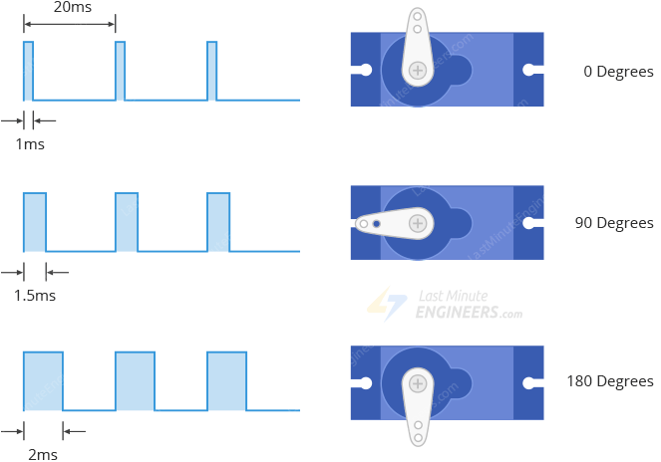

* A short pulse of 1 ms or less will rotate the servo to 0 degrees (one extreme).
* A pulse duration of 1.5 ms will rotate the servo to 90 degrees (middle position).
* A pulse duration of 2 ms or so will rotate the servo to 180 degrees (other extreme).

Pulses ranging from 1ms to 2ms will rotate the servo to a position proportional to the pulse width.

**Arduino devolpment board**

Arduino is an open-source electronics platform based on easy-to-use hardware and software. Arduino boards are able to read inputs - light on a sensor, a finger on a button, or a Twitter message - and turn it into an output - activating a motor, turning on an LED, publishing something online. You can tell your board what to do by sending a set of instructions to the microcontroller on the board. To do so you use the Arduino programming language (based on Wiring), and the Arduino Software (IDE), based on Processing.

Over the years Arduino has been the brain of thousands of projects, from everyday objects to complex scientific instruments. A worldwide community of makers - students, hobbyists, artists, programmers, and professionals - has gathered around this open-source platform, their

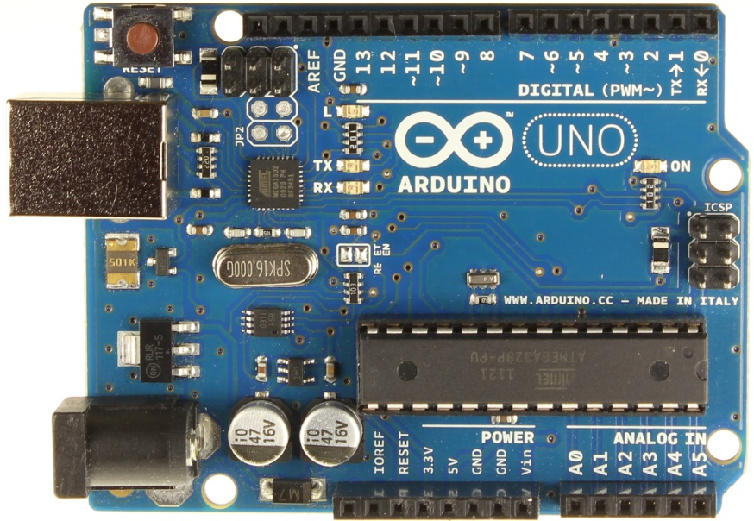

contributions have added up to an incredible amount of accessible knowledge that can be of great help to novices and experts alike.

Arduino was born at the Ivrea Interaction Design Institute as an easy tool for fast prototyping, aimed at students without a background in electronics and programming. As soon as it reached a wider community, the Arduino board started changing to adapt to new needs and challenges, differentiating its offer from simple 8-bit boards to products for IoT applications, wearable, 3D printing, and embedded environments. All Arduino boards are completely open-source, empowering users to build them independently and eventually adapt them to their particular needs. The software, too, is open-source, and it is growing through the contributions of users worldwide.

**ATMEGA328 Microcontroller**

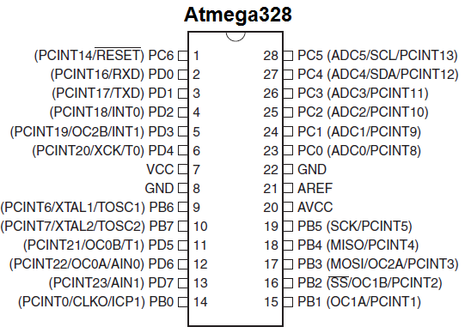

Introduction to ATmega328. ATmega-328 is basically an Advanced Virtual RISC (AVR) micro-controller. It supports the data up to eight (8) bits. ATmega-328 has 32KB internal builtin memory. This micro-controller has a lot of other characteristics. You should also have a look at Introduction to PIC16F877a (it’s a PIC Microcontroller) and then compare functions of these two Microcontrollers.

ATmega 328 has 1KB Electrically Erasable Programmable Read Only Memory (EEPROM). This property shows if the electric supply supplied to the micro-controller is removed, even then it can store the data and can provide results after providing it with the electric supply. Moreover, ATmega-328 has 2KB Static Random Access Memory (SRAM). Other characteristics will be explained later. ATmega 328 has several different features which make it the most popular device in today’s market. These features consist of advanced RISC architecture, good performance, low power consumption, real timer counter having separate oscillator, 6 PWM pins, programmable Serial USART, programming lock for software security, throughput up to 20 MIPS etc. ATmega-328 is mostly used in Arduino. The further details about ATmega 328 will be given later in this section.

**LCD INTERFACE**

**The dot-matrix liquid crystal display controller and driver LSI displays alphanumeric, characters, and symbols. It can be configured to drive a dot-matrix liquid crystal display under the control of a 4 or 8-bit microprocessor. Since all the functions such as display RAM, character generator, and liquid crystal driver, required for driving a dot-matrix liquid crystal display are internally provided on one chip, a minimal system can be interfaced with this controller/driver. A single HD44780U can display up to two 8-character lines (16 x 2).**

**A LCD module, display the information. Micro controllers send the data signals through Pin 11 through 18 and control signal through 8 and 9 of the micro controller. Pin no 3 of the LCD is used to control the contrast by using preset PR1**

**16 x 2 LCD Modules**

HD44780 based LCD displays are very popular among hobbyists because they are cheap and they can display characters. Besides they are very easy to interface with microcontrollers and most of the present day high-level compilers have in-built library routines for them. The interface requires 6 I/O lines of the microcontroller: 4 data lines and 2 control lines.

**A] Required Theory**

All HD44780 based character LCD displays are connected through 14 pins: 8 data pins (D0-D7), 3 control pins (RS, E, R/W), and three power lines (Vdd, Vss, Vee). Some LCDs have LED backlight feature that helps to read the data on the display during low illumination conditions. So they have two additional connections (LED+ and LED-), making altogether 16 pin. A 16-pin LCD module with its pin diagraam is shown below.

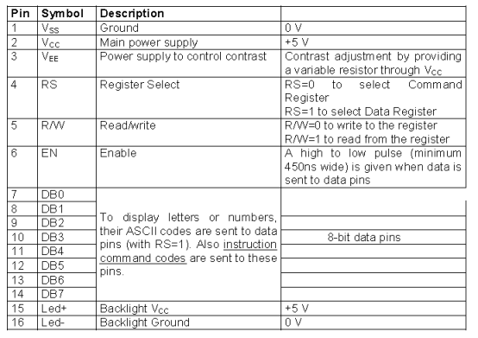

**B] Control pins**

The control pin RS determines if the data transfer between the LCD module and an external microcontroller are actual character data or command/status. When the microcontroller needs to send commands to LCD or to read the LCD status, it must be pulled low. Similarly, this must be pulled high if character data is to be sent to and from the LCD module.

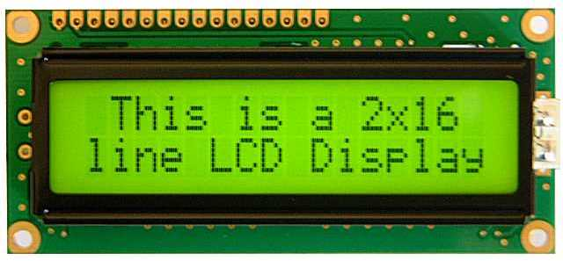

The direction of data transfer is controlled by the R/W pin. If it is pulled Low, the commands or character data is written to the LCD module. And, when it is pulled high, the character data or status information

from the LCD registers is read. Here, we will use one way data transfer, i.e., from microcontroller to LCD module, so the R/W pin will be grounded permanently.

The enable pin (E) initiates the actual data transfer. When writing to the LCD display, the data is transferred only on the high to low transition of the E pin.

**C] Power supply pins**

Although most of the LCD module data sheets recommend +5V DC. Supply for operation, some LCDs may work well for a wider range (3.0 to 5.5 V). The Vdd pin should be connected to the positive power supply and Vss to ground. Pin 3 is Vee, which is used to adjust the contrast of the display. In most of the cases, this pin is connected to a voltage between 0 and 2V by using a preset potentiometer.

**D] Data pins**

Pins 7 to 14 are data lines (D0-D7). Data transfer to and from the display can be achieved either in 8-bit or 4-bit mode. The 8-bit mode uses all eight data lines to transfer a byte, whereas, in a 4-bit mode, a byte is transferred as two 4-bit nibbles. In the later case, only the upper 4 data lines (D4-D7) are used. This technique is beneficial as this saves 4 input/output pins of microcontroller. We will use the 4-bit mode.

**RFID Reader**

Radio Frequency Identification (RFID) Card Readers provide a low-cost solution to read passive RFID transponder tags up to 7 cm away. This RFID Card Reader can be used in a wide variety of hobbyist and commercial applications, including access control, automatic identification, robotics navigation, inventory tracking, payment systems, and car immobilization. The RFID card reader read the RFID tag in range and outputs unique identification code of the tag at baud rate of 9600. The data from RFID reader can be interfaced to be read by microcontroller or PC.

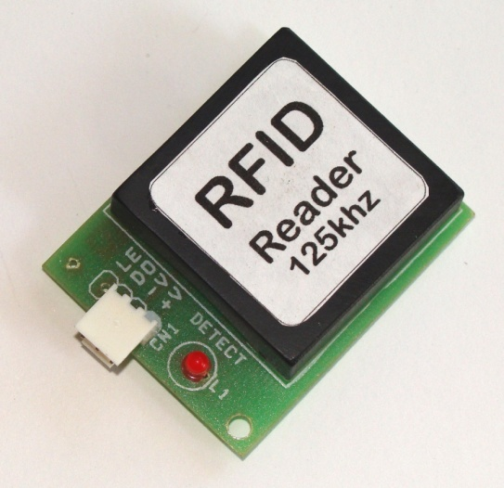

**Features**

* Low-cost method for reading passive RFID transponder tags
* 9600 bps serial interface at 5V TTL level for direct interface to microcontrollers
* LED indicate valid RFID Tag detection
* Range up to 10 cm for 125 Khz RFID Cards or Keychains

**Infrared Sensor**

**Infrared Sensor is most used sensor in wireless technology where remote controlling functions and detection of surrounding objects/ obstacles are involved. This post will discuss about what is Infrared Sensor, its working principle, how it works, types, applications, advantages and disadvantages.**

**IR sensor is a simple electronic device which emits and detects IR radiation in order to find out certain objects/obstacles in its range. Some of its features are heat and motion sensing.**

**IR sensors use infrared radiation of wavelength between 0.75 to 1000µm which falls between visible and microwave regions of electromagnetic spectrum. IR region is not visible to human eyes. Infrared spectrum is categorized into three regions based on its wavelength i.e. Near Infrared, Mid Infrared, Far Infrared.**

**An infrared proximity sensor or IR Sensor is an electronic device that emits infrared lights to sense some aspect of the surroundings and can be employed to detect the motion of an object. As this is a passive sensor, it can only measure infrared radiation. This sensor is very common in the electronic industry and if you’ve ever tried to design an obstacle avoidance robot or any other proximity detection-based system, chances are you already know about this module, and if you don’t, then follow this article as here we will discuss everything about it.**

**IR Sensor Pinout**

**The IR sensor has a 3-pin connector that interfaces it to the outside world. The connections are as follows:**

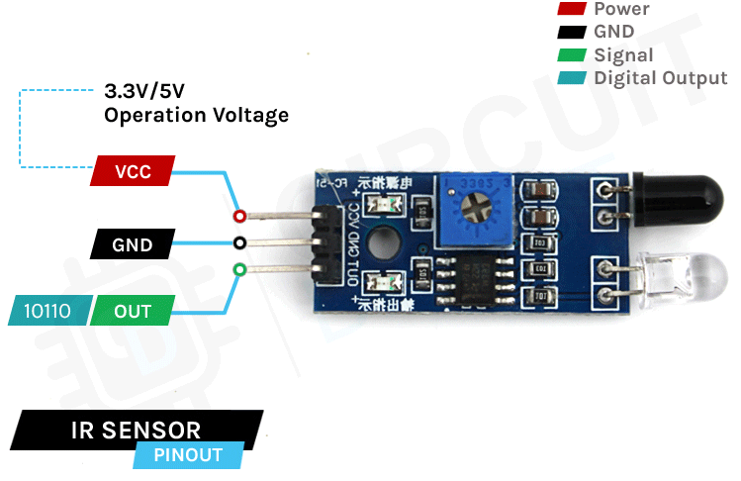

**How Does an IR Motion Sensor Module Work?**

**The working of the IR sensor module is very simple, it consists of two main components: the first is the IR transmitter section and the second is the IR receiver section. In the transmitter section, IR led is used and in the receiver section, a photodiode is used to receive infrared signal and after some signal processing and conditioning, you will get the output.**

**An IR proximity sensor works by applying a voltage to the onboard Infrared Light Emitting Diode which in turn emits infrared light. This light propagates through the air and hits an object, after that the light gets reflected in the photodiode sensor. If the object is close, the reflected light will be stronger, if the object is far away, the reflected light will be weaker. If you look closely toward the module. When the sensor becomes active it sends a corresponding Low signal through the output pin that can be sensed by an Arduino or any kind of microcontroller to execute a particular task. The one cool thing about this module is that it has two onboard LEDs built-in, one of which lights on when power is available and another one turns on when the circuit gets triggered.**

**IR Motion Sensor Module – Parts**

**For most of the Arduino projects, this sensor is used to detect proximity or to build obstacle avoidance robots. This Sensor is popular among beginners as these are low power, low cost, rugged, and feature a wide sensing range that can be trimmed down to adjust the sensitivity.**

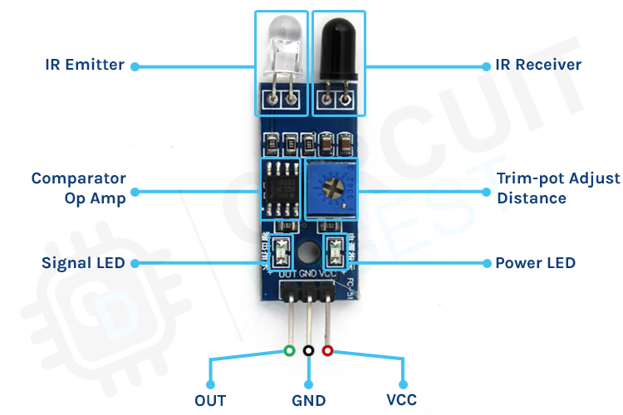

**his sensor has three pins two of which are power pins leveled VCC and GND and the other one is the sense/data pin which is shown in the diagram above. It has an onboard power LED and a signal LED the power LED turns on when power is applied to the board the signal LED turns on when the circuit is triggered. This board also has a comparator Op-amp that is responsible for converting the incoming analog signal from the photodiode to a digital signal. We also have a sensitivity adjustment potentiometer; with that, we can adjust the sensitivity of the device. Last and finally, we have the photodiode and the IR emitting LED pair which all together make the total IR Proximity Sensor Module.**

**PART (COMPONENTS) LIST**

* Arduino MCU
* IR Detection Sensor
* 16 x 2 LCD Display
* Servo Motor
* WIFI Module
* RFID Reader & Tag
* 5V / 12V Power Supply